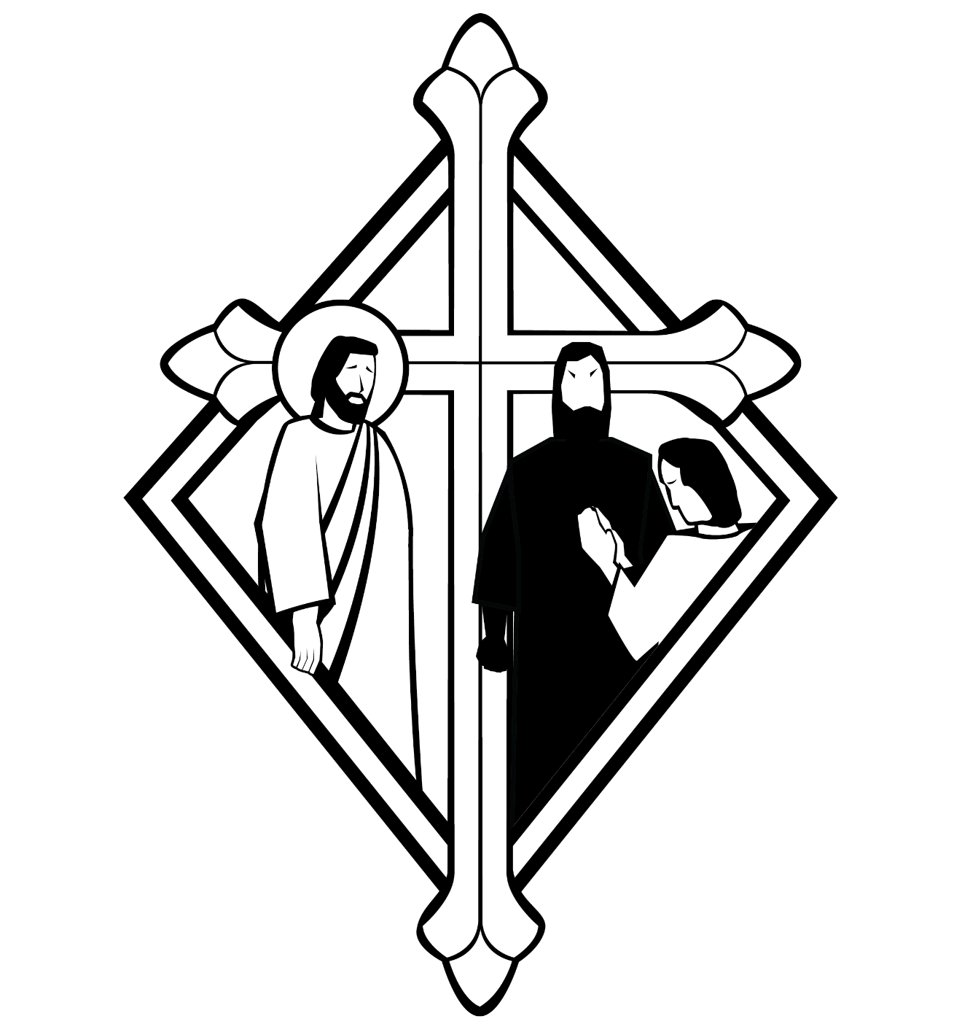
13th Sunday after Pentecost
CHRIST LUTHERAN CHURCH | Lodi, California
August 27, 2023

WELCOME TO WORSHIP
Welcome to Christ Lutheran Church. We pray that your soul will be strengthened by the good news about God’s grace, love, and forgiveness given to us. If you would like to learn more about our church, please speak with our pastor or one of our members after the service.
- Bathrooms are located in the fellowship hall. A changing table is located in the women’s bathroom.
WORSHIP THEME
Who is in and who is out? The world divides people into groups: citizens and foreigners; good guys and bad guys; family, friends, strangers, enemies. But what about the Church? The Church recognizes that not everyone is “in” but also recognizes that Jesus has not set any limits on how many can come in—and he does not legitimize the way we divide people into different groups. The Church is for all, even those who do not feel part of it yet.
The Common Service
The high and holy worship of God is faith in Jesus Christ. Such faith is created and sustained by God’s service to us (the German, “Gottesdienst,” “The Divine Service”). In the Divine Service, the Lord comes to us in His Word and Sacrament to bless and enliven us with His gifts. The Service is not something we do for God, but His service to us received in faith. The liturgy is God’s work. He gives, we receive.
HYMN Jesus Shall Reign, Where’er the Sun | CW’21 380
INVOCATION
M: In the name of the Father, and of the Son ✙ and of the Holy Spirit
C: Amen.
CONFESSION
From God’s Word we know that wherever God puts His name, there He is to bless. In the Old Testament the temple was the place where God graciously caused His name to be present (1 Kings 8:27-30).
God has put His name —Father, Son, and Holy Spirit—on us in Holy Baptism. The Divine Service begins with the Invocation, the words spoken over us at our baptisms. Every Divine Service is for the hallowing of the Lord’s name, which the Small Catechism reminds us is done “when the Word of God is taught in its truth and purity, and we, as the children of God, also lead holy lives according to it” (Matthew 28:18-20).
M: Beloved in the Lord: let us draw near with a true heart and confess our sins to God our Father, asking him in the name of our Lord Jesus Christ to grant us forgiveness.
C: Holy and merciful Father, I confess that I am by nature sinful, and that I have disobeyed you in my thoughts, words, and actions. I have done what is evil and failed to do what is good. For this I deserve your punishment both now and in eternity. But I am truly sorry for my sins, and trusting in my Savior Jesus Christ, I pray: Lord, have mercy on me, a sinner.
Lord, have mercy on us. Christ, have mercy on us. Lord, have mercy on us.

absolution
M: God, our heavenly Father, has been merciful to us and has given his only Son to be the atoning sacrifice for our sins. Therefore, as a called servant of Christ and by his authority, I forgive you all your sins in the name of the Father and of the Son ✙ and of the Holy Spirit.
C: Amen
M: In the peace of forgiveness, let us praise the Lord.
C: Glory be to God on high,
and on earth peace, good will toward men.
We praise you, we bless you, we worship you,
We glorify you, we give thanks to you, for your great glory.
O Lord God, heavenly King, God the Father almighty.
O Lord, the only begotten Son, Jesus Christ;
O Lord God, Lamb of God, Son of the Father,
You take away the sin of the world; have mercy on us.
You take away the sin of the world; receive our prayer.
You sit at the right hand of God the Father; have mercy on us.
For you only are holy; you only are the Lord.
You only, O Christ, with the Holy Spirit,
Are most high in the glory of God the Father. Amen.
PRAYER OF THE DAY
M: The Lord be with you.
C: And also with you.
M: Let us pray.
Almighty and merciful God, it is only by your gift of grace that we come into your presence and offer true and faithful service. Grant that our worship on earth may always be pleasing to you, and in the life to come give us the fulfillment of what you have promised; through Jesus Christ, your Son, our Lord, who lives and reigns with you and the Holy Spirit, one God, now and forever.
C: Amen
FIRST LESSON Isaiah 56:1,6–8
God’s salvation is close at hand for all people: for both the exiles—the lost sheep of Israel—and the foreigner—the one outside the community of God’s people. How do we show we are among God’s people? By doing what is right and coming to the Lord in worship.
This is what the Lord says:
“Maintain justice
and do what is right,
for my salvation is close at hand
and my righteousness will soon be revealed.
⁶ And foreigners who bind themselves to the Lord
to minister to him,
to love the name of the Lord,
and to be his servants,
all who keep the Sabbath without desecrating it
and who hold fast to my covenant—
⁷ these I will bring to my holy mountain
and give them joy in my house of prayer.
Their burnt offerings and sacrifices
will be accepted on my altar;
for my house will be called
a house of prayer for all nations.”
⁸ The Sovereign Lord declares—
he who gathers the exiles of Israel:
“I will gather still others to them
besides those already gathered.”
PSALM Psalm 133-134, page 115
SECOND LESSON Romans 11:13–15, 28–32
All people are bound to disobedience: whether you are “in” or “out” you have sinned and fallen short of the glory of God. You have no rights before the Lord; you can only ask for his mercy.
¹³ I am talking to you Gentiles. Inasmuch as I am the apostle to the Gentiles, I take pride in my ministry ¹⁴ in the hope that I may somehow arouse my own people to envy and save some of them. ¹⁵ For if their rejection brought reconciliation to the world, what will their acceptance be but life from the dead?
²⁸ As far as the gospel is concerned, they are enemies for your sake; but as far as election is concerned, they are loved on account of the patriarchs, ²⁹ for God’s gifts and his call are irrevocable. ³⁰ Just as you who were at one time disobedient to God have now received mercy as a result of their disobedience, ³¹ so they too have now become disobedient in order that they too may now receive mercy as a result of God’s mercy to you. ³² For God has bound everyone over to disobedience so that he may have mercy on them all.
VERSE OF THE DAY Hebrews 4:12
Alleluia. The Word of God is living and active, sharper than any two-edged sword, discerning the thoughts and intentions of the heart. Alleluia.
THE GOSPEL Matthew 15:21–28
Jesus heals the daughter of a bold and persistent Canaanite woman.

²¹ Leaving that place, Jesus withdrew to the region of Tyre and Sidon. ²² A Canaanite woman from that vicinity came to him, crying out, “Lord, Son of David, have mercy on me! My daughter is demon-possessed and suffering terribly.”
²³ Jesus did not answer a word. So his disciples came to him and urged him, “Send her away, for she keeps crying out after us.”
²⁴ He answered, “I was sent only to the lost sheep of Israel.”
²⁵ The woman came and knelt before him. “Lord, help me!” she said.
²⁶ He replied, “It is not right to take the children’s bread and toss it to the dogs.”
²⁷ “Yes it is, Lord,” she said. “Even the dogs eat the crumbs that fall from their master’s table.”
²⁸ Then Jesus said to her, “Woman, you have great faith! Your request is granted.” And her daughter was healed at that moment.

M This is the Gospel of the Lord.
C: Praise be to you, O Christ!

APOSTLES’ CREED
I believe in God, the Father Almighty,
maker of heaven and earth.
I believe in Jesus Christ, his only Son, our Lord,
who was conceived by the Holy Spirit,
born of the Virgin Mary,
suffered under Pontius Pilate,
was crucified, died, and was buried.
He descended into hell.
The third day he rose again from the dead.
He ascended into heaven
and is seated at the right hand of God the Father Almighty.
From there he will come to judge the living and the dead.
I believe in the Holy Spirit,
the holy Christian Church,
the communion of saints,
the forgiveness of sins,
the resurrection of the body,
and the life everlasting. Amen.
HYMN OF THE DAY Your Hand, O Lord, in Days of Old| CW’21 769
SERMON Matthew 15
OFFERTORY
C: Create in me a clean heart, O God,
And renew a right spirit within me.
Cast me not away from your presence
And take not your Holy Spirit from me.
Restore unto me the joy of your salvation,
And uphold me with your free Spirit. Amen.
OFFERING
In response to God’s love and forgiveness, we give back a portion of what he has given us. The members of Christ Lutheran Church have joined to proclaim the gospel to this community. These offerings support that work. While our guests are welcome to participate, they should not feel obligated to do so.
PRAYER OF THE CHURCH
M: O Lord, our God, you are wise and powerful, good and gracious. Your mercies are new every morning. Each day you open your hand and provide for the needs of your children on earth.
C: We praise you for every grace and blessing.
M: Strengthen your Church in all the world. Let your comforting message of salvation in Christ Jesus be proclaimed to troubled souls everywhere.
C: Use our ministries and offerings to extend your healing and your hope.
M: We bring you our requests for the various structures of our society. Bless our national, state, and local governments.
C: Grant us civil servants who are worthy of honor and respect.
M: Grant prosperity to business and industry according to your will. Give employers a sense of fairness toward workers and employees joy and pride in their work.
C: Help us find satisfaction in all work well done.
M: Invigorate the schools of our land. Give success to every effort that helps students read, think, and communicate in ways that will promote an informed and responsible citizenry. Arouse curious minds to discover the wonders of your created order.
C: Give us teachers and students who pursue excellence.
M: Strengthen the family. Give fathers and mothers a renewed commitment to be good parents. Give children and young people the wisdom to see their parents as your representatives.
C: Lead us to love one another as you have loved us.
M: Hear us as we bring you our private petitions.
Silent prayer.
M: Gracious Father, we pray boldly as Jesus taught, with the confidence that you will hear and with the faith that you will respond for our welfare.

LORD’S PRAYER Matthew 6:9-13; Luke 11:2-4
C: Our Father in heaven, hallowed be your name,
your kingdom come, your will be done on earth as in heaven.
Give us today our daily bread; and forgive us our sins,
as we forgive those who sin against us;
and lead us not into temptation, but deliver us from evil.
For the kingdom, the power, and the glory
are yours now and forever. Amen.

THE BLESSING
M: The Lord bless you and keep you.
The Lord make his face shine on you and be gracious to you.
The Lord look on you with favor and ✙ give you peace.
C: Amen.
CLOSING HYMN In Christ There is No East or West | CW’21 860

WELCOME TO CHRIST EV. LUTHERAN CHURCH!
We preach a message of forgiveness, hope and peace
through the death and resurrection of Jesus Christ.
Families and individuals of all ages will find opportunities
both to grow and to serve.
13009 N. Elderberry Ct. Lodi, CA 95242
www.christlodi.org
209-368-6250
Pastor Timothy Leistekow

COPYRIGHT INFORMATION
Content requiring a copyright license is reproduced under OneLicense.net #A-718312. All rights reserved. The Common Service: Texts revised from The Lutheran Hymnal, 1941. Music revised by James Engel. Scripture Quotations: From the Holy Bible, New International Version (NIV 1984), © 1973, 1978, 1984 by Biblica, Inc.

